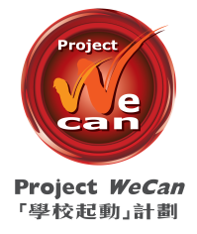

For Immediate Release

Project WeCan Steaming Ahead With Greater Reach

75 Secondary Schools, 66,000 Students and 67 Supporting Partners

First Ever WeCan x HKUST STEAM Awards to Incubate Smart Ideas

6th July, 2018 (Hong Kong) ―― Project WeCan will scale new height with the launch of Phase III from the next school term onwards, Mr Stephen Ng, Chairman of the Project WeCan Committee, announced at the WeCan x HKUST STEAM Awards Ceremony cum WeCan Phase III Launch today. 22 new schools will join the Project starting from September, taking the number of partner schools to 75, supported by 67 organisations and covering 66,000 students.

The launch was announced at a WeCan x HKUST STEAM Award Ceremony officiated by Mr Nicholas Yang, GBS, JP, Secretary for Innovation and Technology; Mr Stephen Ng, Professor Tim Cheng, Dean of Engineering, HKUST; and Dr. Roy Chung, GBS, BBS, JP, Founder and Chairman of the Bright Future Charitable Foundation.

Project WeCan Phase III

Mr Stephen Ng said, “Project WeCan is turning a new page in 2018/19 school term with greater reach. Seven years ago, we initiated an unprecedented “school adoption” model to foster cross-sector collaboration. We decided to expand the Project further last year and thanks to the enthusiastic response from the community, it took us just a few months to garner support from more than 20 organisations, making the expansion possible. Starting from this September, there will be a total of 75 schools under Project WeCan, seven times that of 2011 when the Project was first launched!”

Under Project WeCan, a host of joint schools events are held to foster cross schools learning and best practice sharing. To catch up with the trend, with strong support from The Hong Kong University of Science and Technology (HKUST), a first ever WeCan x HKUST STEAM Awards is organised.

“We are delighted that the programme not only encourages students to solve issues encountered in daily lives by using their STEAM (Science, Technology, Engineering, Arts, and Mathematics) knowledge, it also promotes caring spirit among young people,” Mr Ng added.

Over a hundred students formed 17 teams to create a variety of innovation and technology (I&T) gadgets such as i-shoes, smart bottle opener and automatic sorting recycling bin to help solve issues under the guidance of professors and students from HKUST’s School of Engineering.

WeCan x HKUST STEAM Awards and STEAM Expo
WeCan x HKUST STEAM Awards was kicked off in November, 2017 with over a hundred students from 28 secondary schools (including 24 participating schools of Project WeCan) joining. Seventeen teams were formed and each was supported by two students from HKUST’s School of Engineering.
The winning teams of the Best Innovation Award were selected today by a judging panel formed by Professor Tim Woo and Professor Ben Chan of HKUST and Mr Ricky Wong and Mr Kevin Hui, members of the Project WeCan Committee. The entries were assessed according to criteria including how well the products address the social issues, user-friendliness, application of STEAM theories and techniques, design and cost effectiveness:
 | School | Product
Champion | CCC Rotary Secondary School  Lok Sin Tong Yu Kan Hing Secondary School | Recycling bin in style of a game machine
1st runner up | HHCKLA Buddhist Ching Kok Secondary School | Food Conveying Belt
2nd runner up | HKTA The Yuen Yuen Institute No. 1 Secondary School  The Hong Kong S.Y.C. & I.A. Chan Nam Chong Memorial College | Smart Pillow

All the 17 entries together with the latest winning I&T products from HKUST and other Project WeCan schools are displayed at a STEAM Expo held at Plaza Hollywood between July 6 and July 7. A range of I&T workshops are also open to the public.

Photos:
1. Mr Nicholas Yang, Secretary for Innovation and Technology; Mr Stephen Ng, Chairman of the Project WeCan Committee; principals from 75 partner schools; representations from 67 supporting organisations and others guests attended the ceremony.
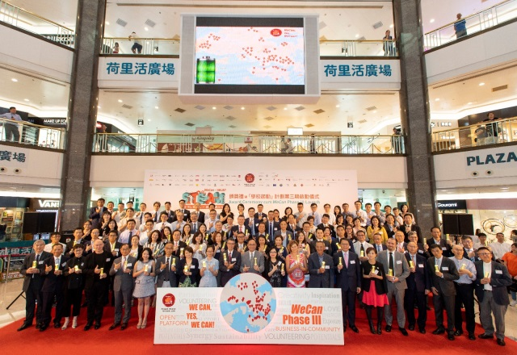
2. Mr Stephen Ng announced the launch of Project WeCan Phase III
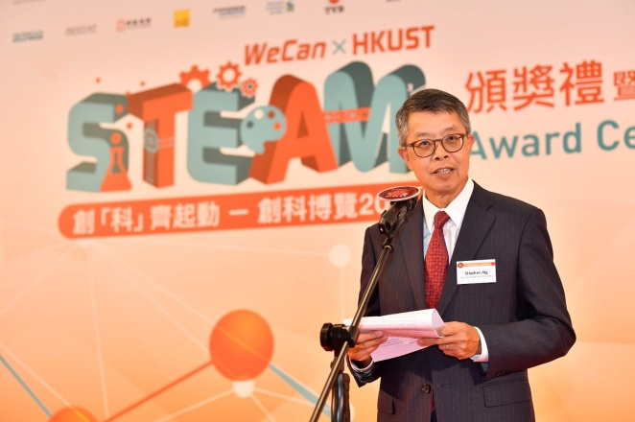

3. Mr Nicholas Yang and Mr Stephen Ng talk to a student about their idea and product at one of the booths
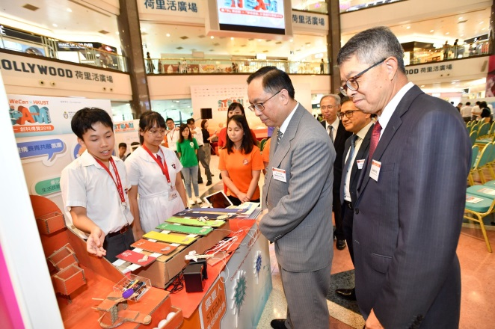
4. The winning teams of the Best Innovation Award were selected today by a judging panel formed by (from the left) Professor Ben Chan and Professor Tim Woo of HKUST; Mr Ricky Wong and Mr Kevin Hui, members of the Project WeCan Committee.
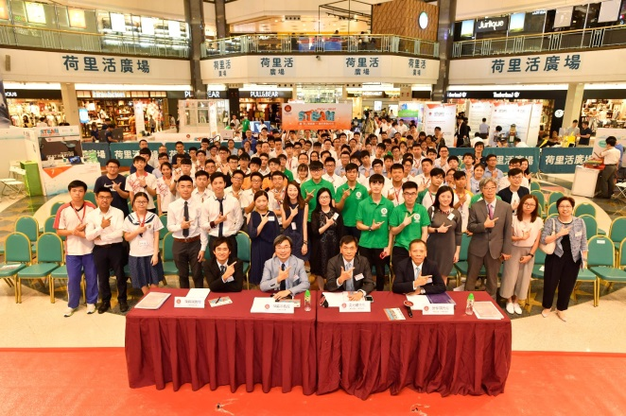

High-resolution photos can be downloaded from here .

About Project WeCan
Project WeCan, a Business-in-Community initiative, aims to provide secondary school students who are disadvantaged in learning with additional resources and care to empower them for pursuing higher education and future careers. Project WeCan is supported by 45 corporates, consulates and other professional organisations. The Project currently has 53 schools participating, benefitting about 50,000 students. In 2018/19 school year, Project WeCan Phase III will be launched with 22 new schools joining, making the total number of schools to 75 and benefitting 66,000 students. Meanwhile, the number of our corporate partners and supporting organisations will also increase to 67 from 45.

Please visit following links for more details:
Website: www.projectwecan.com
Facebook page: www.facebook.com/projectwecanhk
Instagram page: https://www.instagram.com/projectwecan

Appendix: List of New Supporting Organisations

Business Partners (13)
- Café de Coral Holdings Limited
- Caravel Group
- CBRE
- Centaline Property Agency Limited
- Cushman & Wakefield
- DFS Group Ltd
- DHL Global Forwarding (Hong Kong)Limited
- Lark International Group Limited
- Nan Fung Development Limited
- Stephenson Harwood
- Television Broadcasts Limited
- Wang On Properties Limited / Wai Yuen Tong Medicine Holdings Limited
- Yue Hwa Chinese Products Emporium Limited

Consulate Partners (2)
- Consulate General of the Federal Republic of Germany Hong Kong
- Consulate-General of the Republic of Singapore – Hong Kong and Macau

Other Partners (7)
- Alumni UBC Hong Kong
- Cyberport Startup Alumni Association
- European Union Office to Hong Kong and Macao
- Hong Kong Electrical Contractors’ Association
- Hong Kong International Aviation Academy
- Hong Kong Retired Civil Servants Association
- Lions Club of Hong Kong Centennial Passion

###

